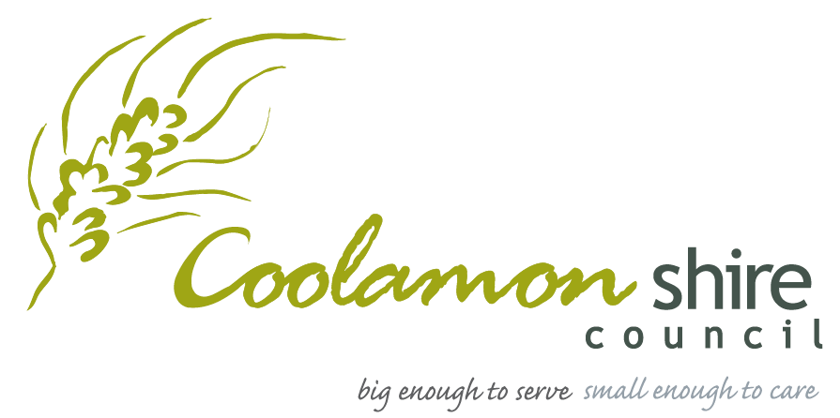
2020 COOLAMON SHIRE EVENT FUNDING PROGRAM

APPLICATION FORM

Applicant Details

Contact Name
Event Name
Postal Address
Mobile / Business Phone
Email

Organisation Details

Incorporated Body (or the name of the sponsoring incorporated body the event is run under)

ABN (if applicable)
Are you Registered for GST | Yes / No
Do you have Public Liability to cover this event? | Yes / No
Description
Please provide a short description and history of your organisation including examples of similar projects you have managed.

Event Details

2020 Event Date (s)
Event Time
Which town will the event take place?
Event Description Please provide a short, one or two sentence description of your project.

Website
Social Media Pages (eg: Facebook)
The Event has been running for how many years (2+)
Anticipated Attendance | Min: Max:
Total Attendance Previously | 2018: 2019:
Do visitors typically stay overnight when attending this event?
If yes, please specify how many nights they would typically stay in Coolamon Shire.

Goals and Objectives

Please outline your goals and objectives in terms of growth and development. You may like to refer to the event program, the variety of activities and experiences on offer, venue, committee, grants and funding, finance, collaboration and partnerships, VIPs and guest speakers, attendance
e.g. number of participants, spectators, stallholders, guests etc

Coolamon Shire Community Strategic Plan

Please outline how your event aligns with the Coolamon Shire Community Plan.

Collaboration

Please provide evidence of collaboration with other events, businesses and/or tourism operators. If possible, please list any groups or organisations that are involved in the project and briefly state the nature of their involvement.

Marketing

Please describe your target market
e.g. families with young children, visiting friends and relatives, car enthusiasts, Coolamon Shire residents, youth of Coolamon
How do you plan to promote your event? Please tick if appropriate.
Council Website (coolamonshire.com.au)  Poster  Flyer/Postcard/Other  Television  Radio  Print Advertising eg: Newspaper, magazines  Word of Mouth  Free Event Listings | Council Website (coolamonshire.com.au)  Direct Mail  E-Newsletters  Community Newsletters  Social Media eg: Facebook, Instagram  PR (Local, Regional, National)  Event Ambassador  Other …………………………………………………………..

Budget

Please supply a budget outlining all anticipated income and expenses. Within the budget, please breakdown your marketing expenditure.
Other items to consider could include:
- Collateral design and print (e.g. flyer, poster, other), Paid advertising (e.g. Television, radio, print, Facebook, digital), Graphic design for digital marketing, Photography, Signage and/or Merchandise

Funding

Maximum amount of grant requested by applicant? (Maximum $3,000 per event)

$.................................................................

Have you or your organisation applied for any other grants or funding opportunities for the 2019 event? Yes/No
If yes, please outline.

Mandatory Supporting Material

Mandatory attachments:
- A copy of the organisation’s most recent annual report and/or financial statements
- A copy of the organisation’s Certificate of Currency for Public Liability Insurance
- If the applicant is not legally incorporated, a letter from a sponsoring incorporated body
- A completed Coolamon Shire Event Registration Form
- A completed Event Budget, highlighting the marketing expenditure
- A completed Risk Assessment

Any Additional Comments

Signature of Applicant

Applicant (Name)
On Behalf of Organisation
I acknowledge that by submitting this application, I have read the Coolamon Shire Community Strategic Plan of which my event directly aligns.
I, being the organiser nominated for the above event hereby consent to the making of this application.
Date
Signature

